District 6710
Organized December 1922
Service Above Self
Vol. No. L Issue No. 37

September 10, 2025

Next Week’s Meeting…

Roni Robinson



Next week’s speaker will be Roni Robinson of “Bridge the Gap” community nonprofit as well as “Roni Round Town” community inclusive marketing. Roni will be discussing upcoming events, specifically the Turkey Extravaganza and the Winter Essentials Drive. Donations request and a list are below.

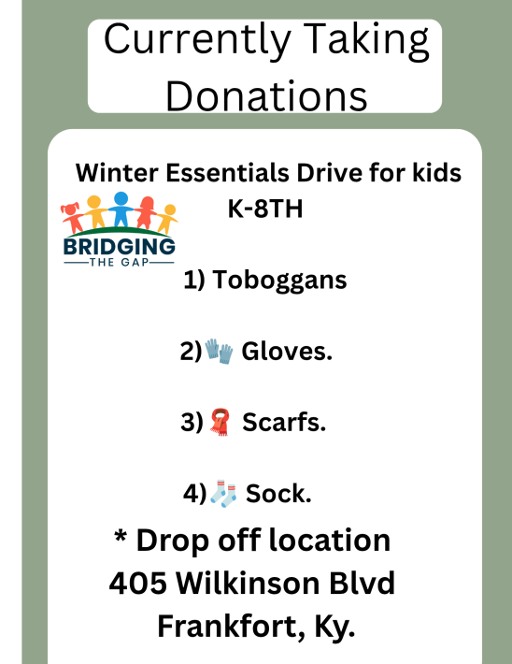

Opening Exercise and Greeter September 17, 2025

Opening exercise will be Lee Troutwine
Greeter will be Tish Shade

Rotary Shirt Order

If anyone is interested in ordering on of the Blue Rotary shirts that some of the members have and are wearing them to some of our club events please get with Paula Rarden (502-229-3018) or at the club meeting ASAP to place an order. The cost has been somewhere around $30 to $35 each.

Welcome New Member !!

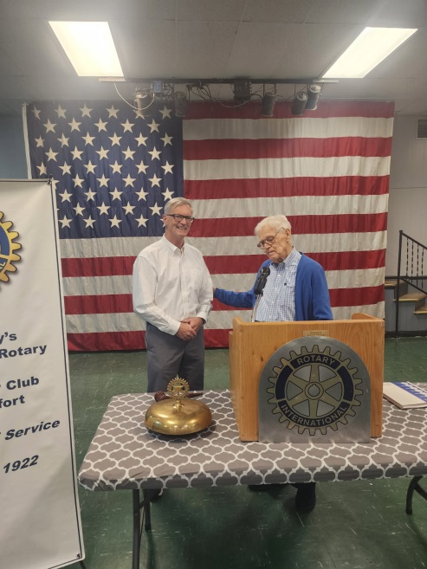

Name: John Heltzel
Address: 1135 Blackberry Dr.
Lawrenceburg, KY 40342
Hm: 502-320-8871
Email: jwsh57@gmail.com
Classification: Humanitarian Causes
Sponsor: Barry Holder, Sr.

Board Action

The board approved new member Peyton Popp contingent upon no negative response after publication in the newsletter.

Monthly Board Meeting

There will be a monthly board meeting of the Directors following the Wednesday 17th weekly meeting. Any member wishing to attend is welcome.

Thanks to this week’s speaker – Teena Halbig

