District 6710
Organized December 1922
Service Above Self
Vol. No. L Issue No. 36

September 3, 2025

Next Week’s Meeting…

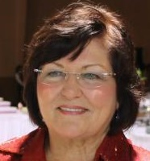

Teena Halbig

Teena Halbig has a scientific background - graduating from University of Louisville with a B.S. degree and a Certificate in Medical Technology. She worked 20 years in the medical field in research at University of Louisville and as a Microbiologist and Virology Supervisor at Jewish Hospital in Louisville.
She began nonprofit works in 1991 to work on clean water issues because cleaner water means better health. Her journey has let her to being recruited to Rotary by Bill Miller a few years ago to become a RC of Frankfort member until her husband needed a shoulder replacement. This caused her to transfer her Rotary membership to RC of Louisville Suburban.
On 5-7-25, Teena received her first Paul Harris pin and certificate. She is RC of Louisville Suburban Chair of International Services Committee and RCLS Chair of Water for Goma in the Democratic Republic of the Congo Global Grant.
Teena is here today to talk about the Rotary Club of Louisville Suburban's Global Grant Project to get Water for Africa - specifically in Goma in the Democratic Republic of the Congo and to ask support from our club.

Opening Exercise and Greeter September 10, 2025

Opening exercise will be Miranda Marston
Greeter will be Dave Weller

Happy Birthday

Happy Birthday to the following Rotarians who will celebrate their birthdays in September: Miranda Marston, Paula Rarden, Sherry Sebastian and Richard Taylor.

Rotary Shirt Order

If anyone is interested in ordering on of the Blue Rotary shirts that some of the members have and are wearing them to some of our club events please get with Paula Rarden (502-229-3018) or at the club meeting asap to place an order. The cost has been somewhere around $30 to $35 each.

Congratulations to the winners of the Froggatta

Dan Glass 1st pictured with President Miranda

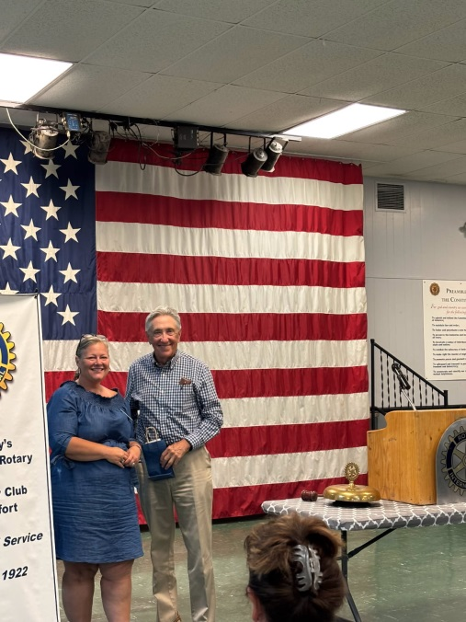

Kathryn Barnes 2nd pictured with President Miranda

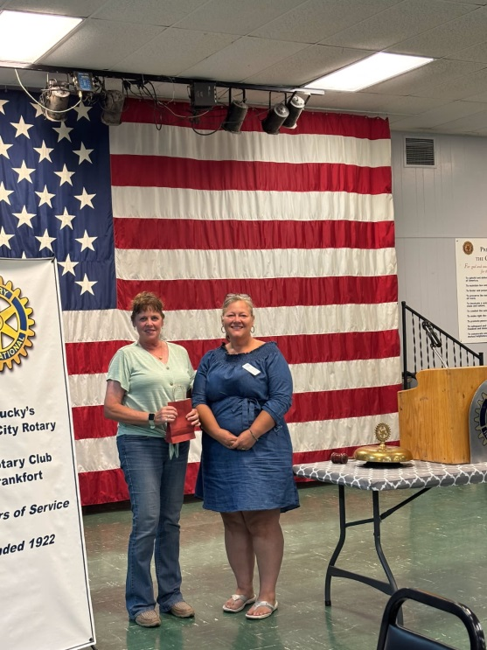

Tammy Barnes 3rd (Peter Smith accepted for her) pictured with president Miranda
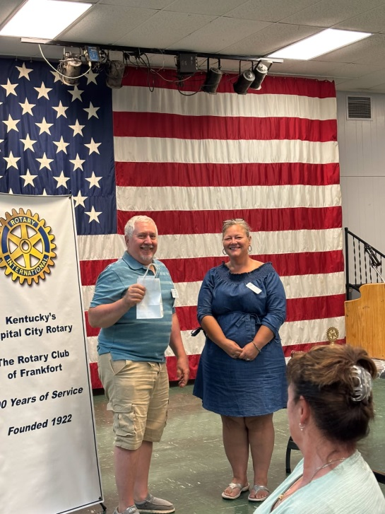

Thanks to this week’s speaker – Dr. Bernard Strenecky

