Rotary Day at the UN 2014

You are cordially invited to attend the 2014 Rotary Day at the United Nations on Saturday, November 1 at the UN in New York City.
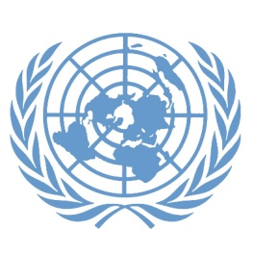
Rotary and the United Nations have a long history of working together and sharing similar visions for a more peaceful world.
Organized by the RI representatives to the UN, this year’s event will feature presentations from senior UN staff and Rotary leaders as well as panel discussions on health, water, literacy, and youth.
High school-age students, including Interactors, Rotaractors and Rotary Youth Exchange participants are encouraged to attend a special session.
For more information visit http://riunday.org/
Please note that the seats will go quickly.
This is a wonderful opportunity to experience one of Rotary’s most outstanding programs, as well as have a great weekend in the Big Apple.
Do not miss it. Yours in Rotary,
Bill
Bill Miller, PDG
District 6710
millerkyun@aol.com
www.globalconnectionstelevision.com

